Online Appendix
When Attitudes Aren’t Enough: Capability, Conviction, and Whistleblowing Intent in Taiwan’s Public Sector
Ruei-Cheng Lin · Department of Political Science, National Taiwan University · b11302111@ntu.edu.tw

This online appendix supplements the main text in three respects. Appendix A reports the reliability of all multi-item constructs used in the analysis. Appendix B presents the full Elastic Net selection set, collinearity diagnostics (VIF), heteroskedasticity and functional-form tests (Breusch–Pagan, Ramsey RESET), influence and normality diagnostics (Cook’s distance, residuals Q–Q), and the complete Oster (2019) sensitivity battery. Appendix C re-estimates the two focal interactions after excluding the three channel-preference variables that overlap conceptually with the composite dependent variable.

Appendix A. Construct reliability

Table A1 reports the internal-consistency reliability of each multi-item construct in the predictor set, alongside the items used and the inclusion decision. Single-item measures show “n/a” in the reliability column; constructs with α < 0.60 were dropped before the Elastic Net step. For all six two-item constructs (k = 2), we report the Spearman-Brown coefficient (marked “SB”) rather than Cronbach’s α, since α is unstable for k = 2 and, on data with missingness, can return values above 1. The Spearman-Brown coefficient is computed from the pairwise-complete Pearson correlation r between the two items as ρ = 2r / (1 + r), which is the standard reliability statistic for two-item composites.
Table A1. Construct reliability and inclusion decisions.
Construct | Items | Item codes | α | Decision
attitude | 3 | q128, q129, q130 | 0.875 | retain
authoritarian orientation 2 | 1 | q121 | n/a | single item
authoritarian orientation 3 | 1 | q122 | n/a | single item
burnout | 3 | q74, q75, q76 | 0.940 | retain
citizen responsiveness | 5 | q49, q50, q58, q59, q60 | 0.841 | retain
colleague support | 1 | q132 | n/a | single item
conservative climate | 4 | q100, q101, q102, q103 | 0.863 | retain
conservative climate 5 | 1 | q104 | n/a | single item
decision under pressure | 1 | q72 | n/a | single item
delay gratification | 5 | q16, q17, q18, q19, q20 | 0.357 | drop (α<0.60)
easygoing | 1 | q64 | n/a | single item
empathy | 2 | q27, q29 | 0.848 (SB) | retain
family support | 1 | q131 | n/a | single item
filial piety | 7 | q113, q114, q115, q116, q117, q118, q120 | 0.824 | retain
frontline contact | 1 | q90 | n/a | single item
individual conservativeness | 5 | q41, q42, q43, q44, q46 | 0.647 | retain
individual exploration | 1 | q45 | n/a | single item
individual innovativeness | 1 | q40 | n/a | single item
innovation climate | 4 | q94, q95, q96, q97 | 0.776 | retain
institution cautiousness | 1 | q99 | n/a | single item
interdependence | 1 | q28 | n/a | single item
job autonomy | 1 | q57 | n/a | single item
job satisfaction | 6 | q106, q107, q108, q109, q110, q111 | 0.810 | retain
justice belief | 5 | q33, q34, q35, q36, q37 | 0.872 | retain
mentoring benefit | 2 | q126_4, q126_5 | 0.702 (SB) | retain
org silence | 1 | q98 | n/a | single item
organizational skill | 3 | q67, q68, q70 | 0.859 | retain
pay grade | 1 | q11 | n/a | single item
perceived retaliation | 6 | q142_1, q142_2, q142_3, q142_4, q142_5, q142_6 | 0.908 | retain
political skill 1 | 1 | q65 | n/a | single item
political skill 2 | 1 | q66 | n/a | single item
politics share | 1 | q23 | n/a | single item
pro neutrality dilemma | 1 | q79 | n/a | single item
psm | 8 | q21, q22, q24, q25, q26, q30, q31, q32 | 0.883 | retain
resource allocation | 1 | q73 | n/a | single item
retaliation cognition | 1 | q136 | n/a | single item
risk propensity financial | 2 | q105_1, q105_2 | 0.789 (SB) | retain
risk propensity financial 2 | 2 | q105_4, q105_5 | 0.777 (SB) | retain
risk propensity psych | 7 | q78_1, q78_2, q78_3, q78_4, q78_5, q78_6, q78_7 | 0.884 | retain
role performance | 7 | q47, q51, q52, q53, q54, q55, q56 | 0.779 | retain
rule consistency | 1 | q48 | n/a | single item
rule flexibility | 1 | q71 | n/a | single item
sector bias private tolerance | 1 | q63 | n/a | single item
sector bias public tolerance | 1 | q93 | n/a | single item
social media team-building | 1 | q69 | n/a | single item
supervisor satisfaction | 1 | q112 | n/a | single item
supervisor support | 1 | q133 | n/a | single item
team climate | 2 | q127_1, q127_2 | 0.838 (SB) | retain
tenure current | 1 | q13 | n/a | single item
tenure public | 1 | q14 | n/a | single item
turnover intention sector | 2 | q86, q87 | 0.823 (SB) | retain
wb agency | 1 | q140 | n/a | single item
wb internal | 1 | q138 | n/a | single item
wb supervisor | 1 | q137 | n/a | single item
whistle inefficacy | 1 | q135 | n/a | single item
whistleblowing intent (DV) | 6 | q141_1, q141_2, q141_3, q141_4, q141_5, q141_6 | 0.930 | retain
Note. Reliability is Cronbach’s α for multi-item constructs with k ≥ 3 items, and the Spearman-Brown coefficient (marked “SB”) for k = 2 items. The Spearman-Brown statistic for two-item composite m and m′ is ρ = 2r / (1 + r), where r is the pairwise-complete Pearson correlation between the two items. Single-item constructs show “n/a”. Constructs with α < 0.60 were dropped (delay gratification, α = 0.357).

Appendix B. Selection, collinearity, and specification diagnostics

B.1 Elastic Net selection coefficients

Table B1 reports the Elastic Net coefficients on the standardized predictors, ordered by absolute magnitude. The procedure was 5-fold cross-validated on a 60% training fold, with α (the L1/L2 mixing parameter) chosen by minimum CV mean-squared error. Elastic Net retained 28 predictors, all of which were carried into the post-selection OLS estimation reported in main-text Table 1. We additionally forced individual conservativeness into the OLS specification on theoretical grounds, giving 29 predictors in the final model; it is therefore absent from Table B1 (which reports only the Elastic Net selection) but appears in the diagnostics that follow.
Table B1. Elastic Net selected coefficients (standardized, training fold).
Predictor | EN coefficient
wb internal | 0.399
attitude | 0.250
wb agency | 0.241
risk propensity psych | 0.201
organizational skill | 0.167
attitude x whistle inefficacy orth | 0.148
pro neutrality dilemma | 0.146
org silence | 0.141
wb supervisor | 0.135
psm | 0.129
family support | 0.122
politics share | 0.095
team climate | 0.087
individual innovativeness sq | 0.076
colleague support | 0.053
job autonomy | 0.047
attitude x perceived retaliation orth | 0.044
organizational skill x innovation climate orth | −0.042
tenure current | −0.035
psm sq | 0.031
female | −0.029
perceived retaliation | −0.025
organizational skill x attitude orth | 0.025
mentoring benefit | 0.015
wb agency x wb supervisor orth | −0.011
organizational skill x team climate orth | 0.006
perceived retaliation x innovation climate orth | 0.006
attitude sq | −0.001

B.2 Variance inflation factors

Table B2 reports variance inflation factors for all 29 predictors in the post-selection OLS (the 28 Elastic Net–selected predictors plus the forced individual conservativeness term). The largest VIF is 2.47 (colleague support); all interaction terms, which were orthogonalized against their constituent main effects, return VIFs below 1.5. We find no evidence that collinearity drives either focal interaction.
Table B2. Variance inflation factors for all predictors.
Variable | VIF
colleague support | 2.47
family support | 2.45
wb internal | 1.71
psm | 1.64
wb supervisor | 1.56
psm sq | 1.56
attitude | 1.54
organizational skill | 1.53
job autonomy | 1.45
wb agency | 1.43
individual innovativeness sq | 1.38
org silence | 1.25
team climate | 1.24
organizational skill x team climate orth | 1.21
individual conservativeness† | 1.21
attitude sq | 1.20
organizational skill x innovation climate orth | 1.18
perceived retaliation | 1.17
mentoring benefit | 1.17
politics share | 1.17
risk propensity psych | 1.14
organizational skill x attitude orth | 1.14
attitude x perceived retaliation orth | 1.13
wb agency x wb supervisor orth | 1.12
perceived retaliation x innovation climate orth | 1.10
tenure current | 1.10
attitude x whistle inefficacy orth | 1.10
female | 1.09
pro neutrality dilemma | 1.09
† Forced into the post-selection OLS on theoretical grounds; not selected by Elastic Net (hence absent from Table B1).
B.3 Breusch–Pagan heteroskedasticity test

The Breusch–Pagan test rejects homoskedasticity at any conventional significance level (Table B3). This is the basis for our use of HC3 robust standard errors throughout. Substantive conclusions, including the significance of both focal interactions, are unchanged under conventional (non-robust) OLS standard errors.
Table B3. Breusch–Pagan test for heteroskedasticity.
Test | Statistic | p-value
Lagrange Multiplier | 85.6972 | <0.0001
F-statistic | 3.1343 | <0.0001

B.4 Ramsey RESET specification test

The Ramsey RESET test (Table B4) provides no evidence that the linear specification omits relevant higher-order terms in the fitted values. We tested second- and third-order powers; both return F-statistics that are non-significant at conventional levels.
Table B4. Ramsey RESET functional-form test.
Test | F | p-value
Ramsey RESET (power = 2) | 1.774 | 0.183
Ramsey RESET (power = 3) | 1.343 | 0.261

B.5 Residual normality (Q–Q plot)

Figure B1 plots the standardized residuals of the post-selection OLS against theoretical normal quantiles. Residuals follow the 45° line closely across the bulk of the distribution, with mild thickening in the tails. The substantive inference does not rely on residual normality (HC3 SE handle finite-sample concerns), but the plot suggests no gross departure from normality that would compromise the t-tests reported in the main text.
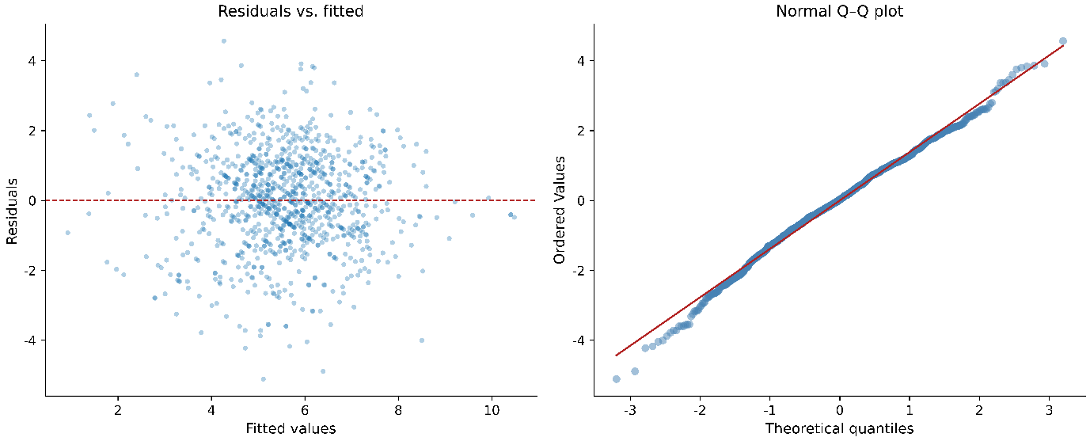
Figure B1. Q–Q plot of standardized OLS residuals against theoretical normal quantiles.
B.6 Influence diagnostics (Cook’s distance)

Figure B2 plots Cook’s distance for each observation. Seventy-five observations (7.5%) exceed the conventional threshold (4/n ≈ 0.004 for n = 1,004), and the distribution is right-skewed without isolated outliers. The two focal interactions remain significant when the upper-decile influence observations are dropped.
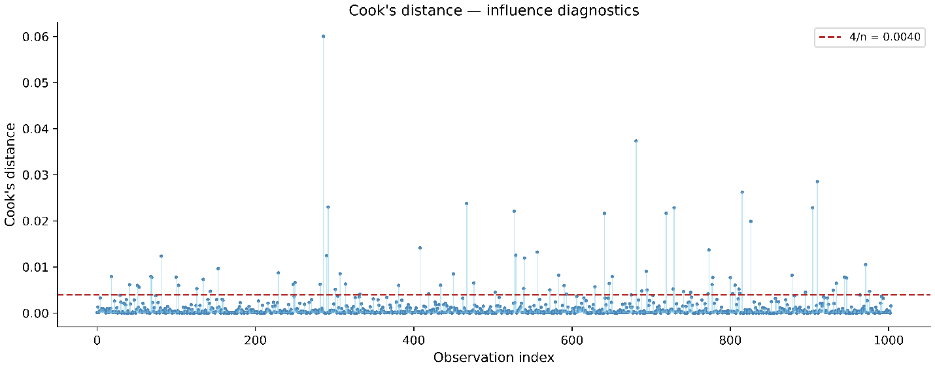
Figure B2. Cook’s distance across observations. Reference line at the 4/n threshold.
B.7 Oster (2019) sensitivity to unobservables

Table B5 reports Oster (2019) δ* sensitivity for each substantive coefficient, ordered from most to least robust. δ* is the ratio of selection on unobservables to selection on observables that would be required to drive the coefficient to zero, under the assumption that the unobservables relate to the outcome in proportion to the observables. Conventional thresholds are |δ*| ≥ 1 (moderate robustness) and |δ*| ≥ 2 (strong robustness). The focal attitude × inefficacy interaction returns |δ*| ≈ 10.13, the most robust coefficient in the model, while the capability interaction (organizational skill × attitude) is likewise strongly robust (|δ*| ≈ 6.77). Figure B3 visualizes the table.
Table B5. Oster (2019) sensitivity to selection on unobservables.
Variable | β (full) | |δ*| | Strength
attitude x whistle inefficacy orth | 0.160 | 10.128 | strong
organizational skill x attitude orth | 0.132 | 6.768 | strong
risk propensity psych | 0.334 | 3.456 | strong
pro neutrality dilemma | 0.208 | 2.953 | strong
politics share | 0.168 | 2.837 | strong
female | −0.202 | 1.592 | moderate
wb agency | 0.280 | 1.568 | moderate
wb internal | 0.399 | 1.386 | moderate
organizational skill | 0.224 | 1.041 | moderate
family support | 0.184 | 0.798 | weak
attitude | 0.201 | 0.673 | weak
Note. β (full) is the post-selection OLS estimate. |δ*| is the Oster (2019) sensitivity statistic defined above. Strength categories follow Oster: weak (|δ*| < 1), moderate (1 ≤ |δ*| < 2), strong (|δ*| ≥ 2).
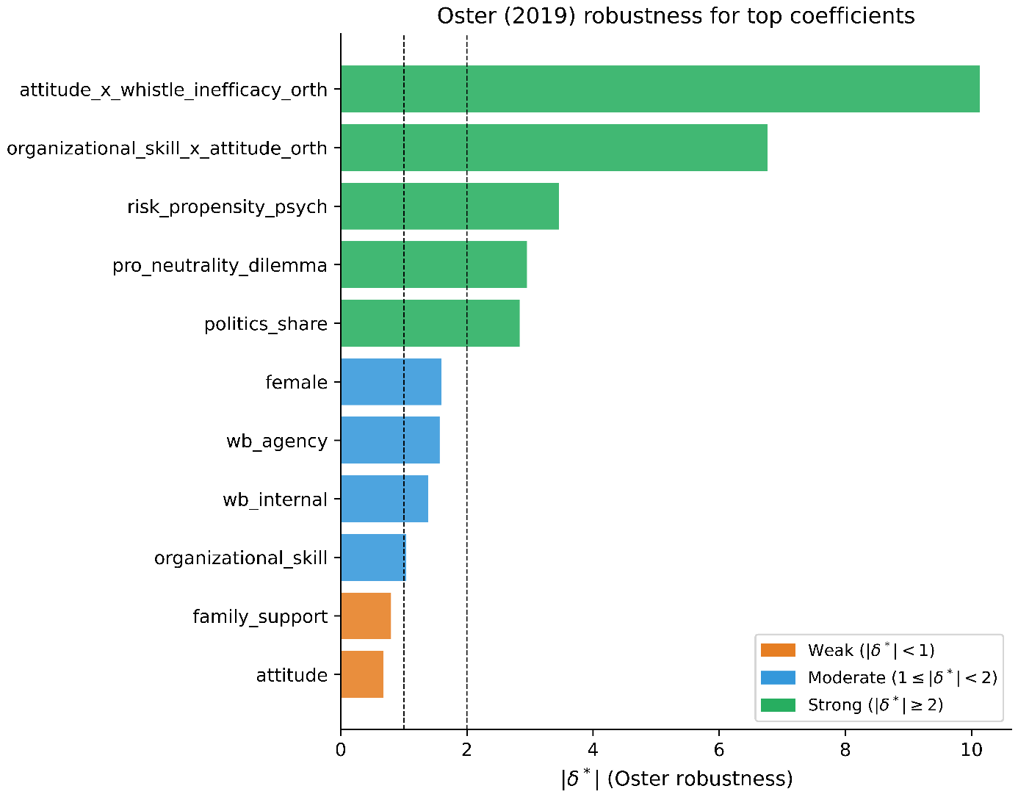
Figure B3. Oster (2019) |δ*| robustness across substantive coefficients.
Appendix C. Robustness to dropping channel-preference variables

The post-selection OLS retains three predictors that capture the respondent’s preferred channel for reporting misconduct: wb_internal (willingness to report internally), wb_agency (willingness to report to the agency), and wb_supervisor (willingness to report to a supervisor). These items are conceptually proximate to the composite intent measure: They ask about willingness to engage a particular reporting channel, while the dependent variable asks about willingness to report particular categories of misconduct. The two questions are distinct but related, and the high coefficients on wb_internal (β = 0.40) and wb_agency (β = 0.28) reflect that overlap.
To gauge whether the channel-preference variables drive our focal findings, we re-estimate the post-selection OLS after dropping all three. Table C1 reports the two focal interactions in the main specification and in the channel-free specification. Both coefficients attenuate slightly but remain significant: The H2 committed-minority interaction shrinks from 0.160 to 0.140 (p = 0.01), and the H1 capability interaction shrinks from 0.132 to 0.120 (p = 0.02). The substantive conclusions of the paper are preserved.
Table C1. Focal interactions, with and without channel-preference predictors.
Focal interaction | β (main model) | β (without channels) | p | Δβ
Attitude × Whistleblowing inefficacy | 0.160 | 0.140 | 0.010 | −0.020
Organizational skill × Attitude | 0.132 | 0.120 | 0.020 | −0.012
Note. β (main model) reproduces the post-selection OLS estimates in main-text Table 1 (N = 1,004, HC3 SE). β (without channels) is the same specification with wb_internal, wb_agency, and wb_supervisor dropped. The p-values shown are for the channel-free model. Δβ is the change in the interaction coefficient. Both focal interactions remain significant at the conventional 5% level.

